2

Partnership Planning Worksheet
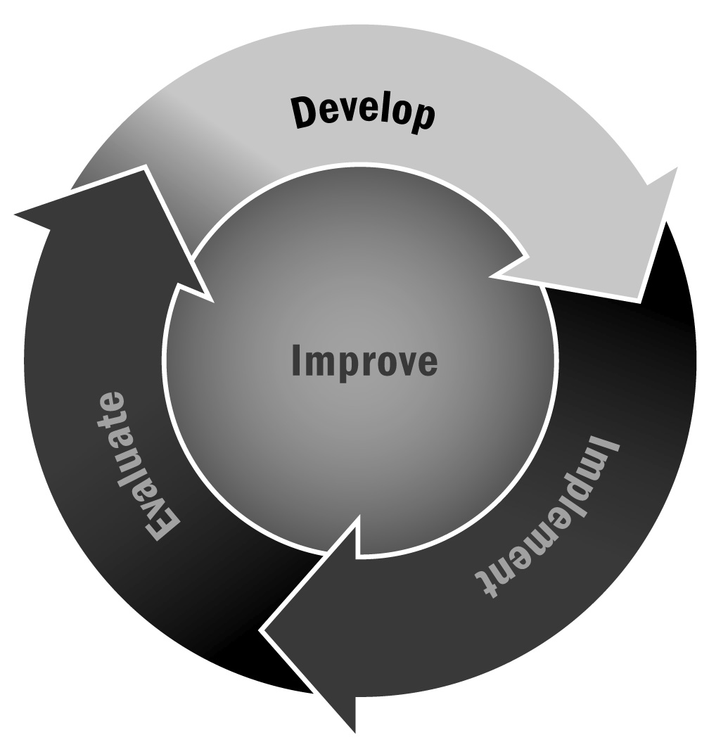
In Chapters 1 and 3, you learned that developing and maintaining successful partnerships is vitally important for afterschool and expanded learning programs. By clearly establishing roles for each partner you will help set the stage for a successful relationship.
Directions: Use this tool to think through the details of your partnership, including any potential issues that may arise. In some cases, the decisions made will require a joint response, while other instances will require individual responses. The tool shows when a joint response is needed. NOTE—the responses on this worksheet do not need to be developed all in one meeting or session. It can be used to first explore potential intersections of goals, then be used later to help identify the role required of each organization.
Topics of Conversation | Afterschool and Expanded Learning Program Priorities | Partner Organization Priorities
Goals for the Partnership

Responsibilities | Afterschool and Expanded Learning Program Role | Partner Organization Role
Day-to-Day Program and Activity Management
Programming Decisions
Staffing
Staff Training
Providing Materials
Budget Decisions
Decisions Regarding Facilities Use/Space
Program Evaluation
Communication and Reporting Strategies

Respective Responsibilities | Afterschool and Expanded Learning Program and Partner Organization
Governance Structure and Processes | Joint Response:
Method for Establishing Meeting Time and Place, and Meeting Preparation Responsibilities | Joint Response:
Communication Structure That Encourages Partners to Discuss Perceptions, Satisfaction Levels, and Suggestions for Relationship Building | Joint Response:
Processes for Resolving Conflict Among Youth and Adults | Joint Response:
Process for Ensuring That Partners Receive Recognition for Contribution to Mission | Joint Response:
Process for Evaluating Usefulness of the Relationship | Joint Response:
Other: | Joint Response:
Other: | Joint Response:

